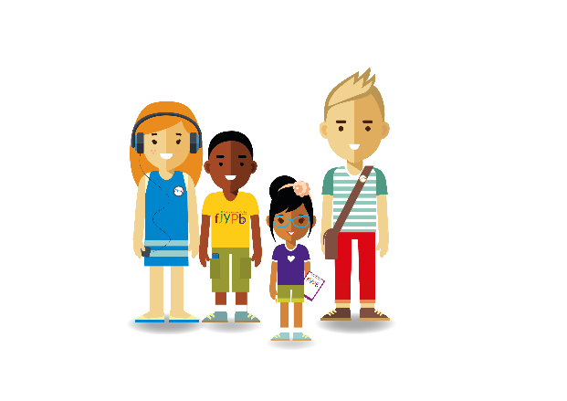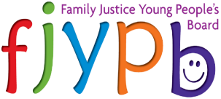Members of the Family Justice Young People Board have complied a list of words and phrases that they often hear during family law proceedings. They want to encourage all professionals to stop using these and to think about the ways in which they speak to children and young people and how they refer to them in their reports, on file and to other professionals.

I am not a ***CASE*** or a ***number***. I am a person, so please don't talk about how many cases you have or about your case plan. Talk about how many children and young people you are helping.

A ***connected child*** usually refers to my brothers or sisters. They are not connected. They are my family. Also don’t use the word **SIBLINGS**. Say brothers and sisters because this is how I refer to them.

I am not a ***subject*** ***child*** or an object. I would like to be referred to by my name. The proceedings are about my life. The only thing worse than being referred to as a subject child is a ***non-subject child***. Please think about how you talk about the people involved in family law proceedings.

***Looked After Child (LAC).*** This makes me feel patronised and as though I am different. I am a child like any other. Please don’t label me.

I do not have ***behaviour issues,*** but rather you have observed some aspect to the way that I respond to things can be challenging. Write or talk about what you have observed and the possible causes. Put yourself in my shoes. How would you react? Is my reaction a fair response to my situation?

***Beyond parental control.***This is very upsetting to hear and to read about. It makes me feel that I have no hope or that there is no way to change or make things better. Think about how you describe me. What will I think about myself in later years if I read this?

I am not a problem or a ***problem child***, but I may be faced with problems and challenges that make me react in a way that is difficult to others. Think about how the label 'Problem Child' will affect me.

***Access***, and ***contact*** suggests that I need permission. Who gives the permission? What happens if they say no? Also, what are my rights? Instead talk or write about me ‘*spending time with’* a member of my family.

***Section 7, Section 47, Section 37.*** Please can you make sure that I understand why you need to write a report about my life and current situation, who the report will be shared with and I will want to share with you my thoughts too.

***CIAF, ISO, ICO, CYP*** Any sort of acronyms in my notes is confusing. I am not sure what they mean, and I don’t understand how they are important to me. Write or say them in full and give me an explanation.

***Third party or parties.*** What does this even mean to me? Please refer to them by name.

Me and my family are not ***service users.*** This sounds too formal and unconnected. We are a family and I am a child

I am unique and I want you to write or talk about my uniqueness and not that I am a ***classic case***.

It is really common to talk about ***court hearings*** with their titles or acronyms such as: FHDRA, DRA, and IRH. I do not know what these are, why they need to take place, who will be there and what the possible outcomes maybe. Please think about this when talking to me, make sure I understand that a court hearing is, what the outcome is likely to be and how this will affect me.

My ***diversity*** is part of me and it allows me to express who I am and the things that are important to me. I want you to talk to me and explore my diversity. Talk and write about my diversity in the way I have described to you. Do not write on my file or on report no ‘***diversity issues’***.

***Kids*** – we are not goats, but children and young people. Think about how you use the word ‘kid(s)’. It can feel patronising.

My wishes and feelings are not ***fantasy*** but rather my hopes for my future. So please don’t talk about or write about me as if I live in a fantasy world.

Rather than talk or write about my ***split family*** because this feels negative or a **blended family** as this can feel confusing, just explain what this means for me.

I will want to know when I can spend time with my parents/carers and family members. The term ***Shared care*** feels strange and as though I need ‘care’. Just explain to me when I spend time with my family.

***Orders***: Child Arrangements Orders; Prohibited Steps Orders; Secure Order and court terminology is very confusing. I may not understand what an order is or what it means. Talk to me and make sure I understand what decisions have been made about my life and write clearly about them in my file and how it will affect me. Also ***16.4s, S7, S31 etc.*** What do these numbers mean to me?

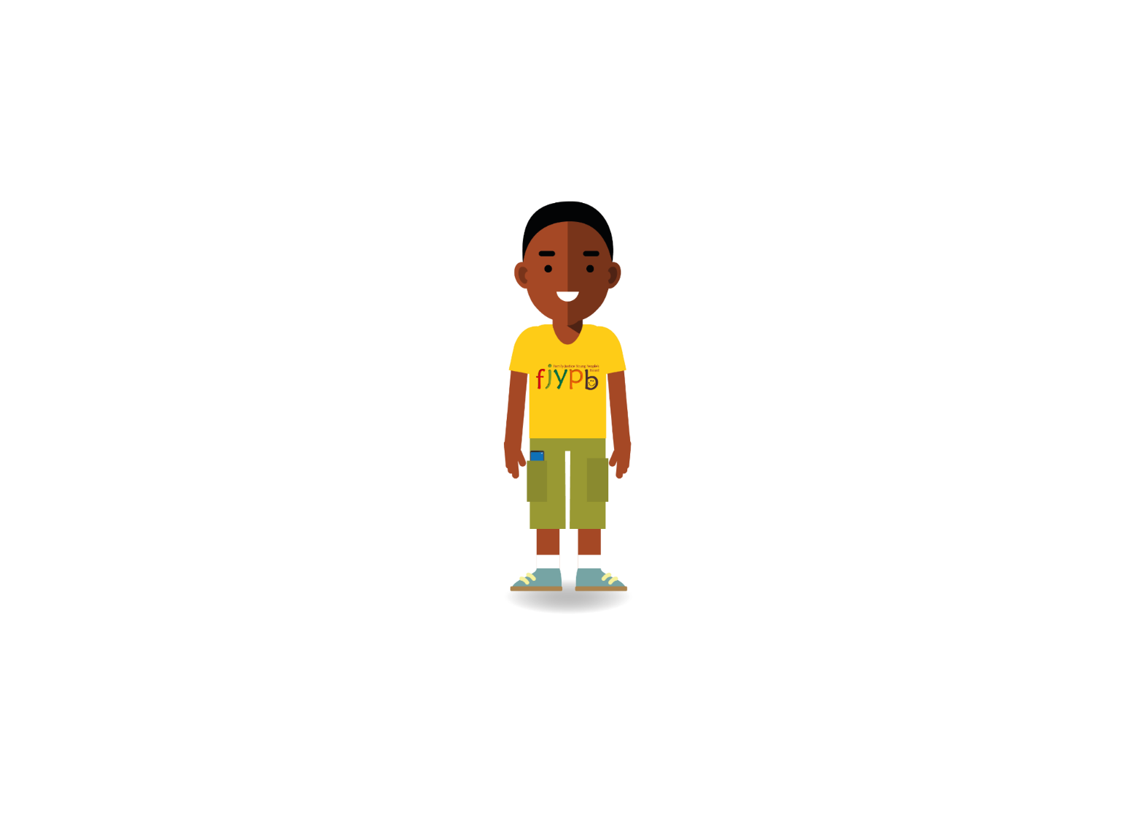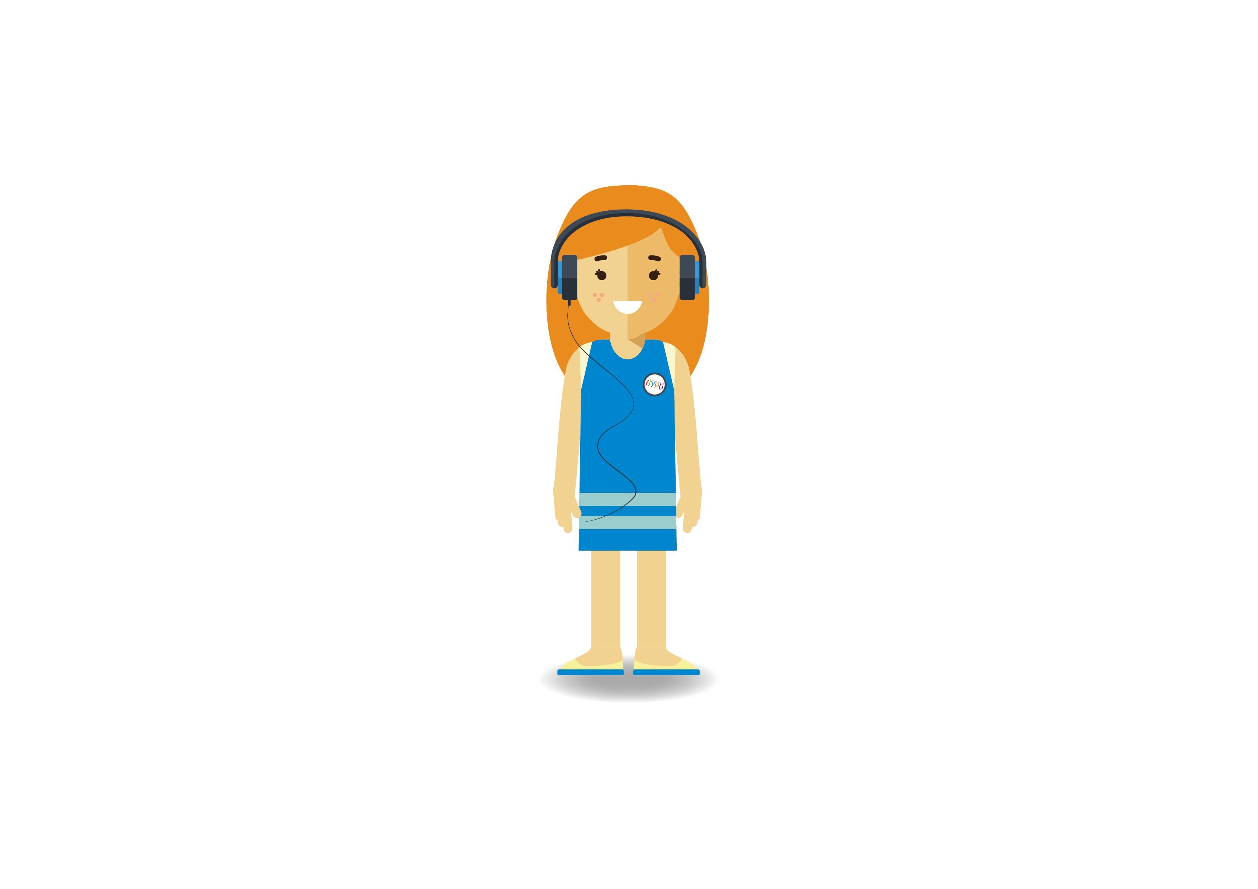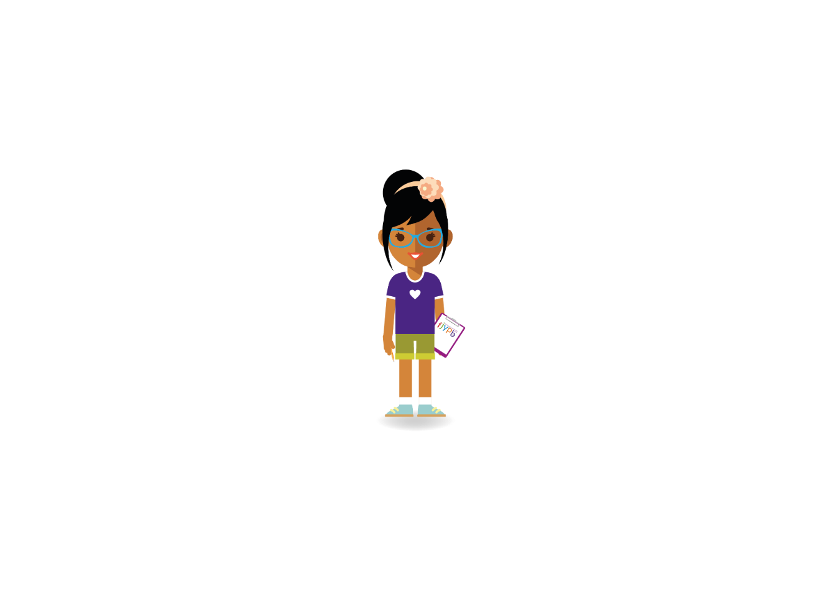

**REMEMBER**

To ***Mind Your Language*** when you speak to me, about me or write about me. Correct others if they don’t consider the language that they use.